*Case Study 4.1:* **Pizza ? Just eat !** V.2.2



Two Pizza meals are shown in the following. Between the two examples lie about 1.5 years of user experience, and a further tuning of the autoISF FCL.

Method

FCL (no carb inputs, no user boli) with dev variant of AAPS w/autoISF 2.2.8, respectively, with autoISF 3.0

Lyumjev 100 (DIA 7h) in Combo pump w/ 10mm Teflon cannula (0-48h)

2 x G6 overlapping (see case study 1.5; sensors used ~ d3 – d15; xDrip, no smoothing in 12 AAPS)

TDD ~ 35 U; profile basal ~ 14 U (0.41…0.75 U/h); profile_ISF 36…44 mg/dl/U;

Key settings (used not only for Pizza and alike meals, but tuned for the entire spectrum):

|  |  |  |
| --- | --- | --- |
| Key settings **\*)** | Original ,at Pizza meal 1 | Later, at Pizza meal 2 |
| autoISFmax | 2.0 | 2.5 |
| autoISFmin | 0.5 | 0.4 |
| SMB range extention >120 | 2.9 ? | 2.9 ? |
| Iob threshold | 5.8 U ? | 60% * 10 U (=6.0 U) ? |
| Autosens | ON (0.9 – 1.1) | OFF |
| bgAccel_ISF_weight | 0.16 | 0.22 |
| bgBrake_ISF_weight | 0.08 | 0-11 |
| delta resp. pp_ISF_weight | 0.10 (? delta) | 0.02 (pp) |
| higher_ISF-range_weight | ? | ? |
| lower:ISF-range_weight | ? | ? |
| dura_ISF_weight | 0.8 | 0.6 |

? not sure about some un-important settings; might try to look them up for a later update

**\*) Do not copy values into your system.** FCL e-book section 4.1 explains why

*If you just want to have a glimpse what to expect with Pizza in a well tuned FCL*), skip the next sections, and go to headline* Pizza meal 2*, starting on page 8*.

*\*) Notes:* 1) Tuning *exclusively for Pizza* could produce results that are a touch better. But what we are after in FCL, is to find settings *for our personal variety of meals* that principally allow a hands-off FCL.

2) High carb meals must start at low bg, or with bg coming down and pos. iob. The FCL provides that. But, setting an EatingSoonTT is time-uncritical and sometimes helpful (see FCL e-book, end of section 2.5).

Pizza meal 1

A „standardized“ commercial type of Pizza …

Wagner Veggie Pizza with *extra ham* *and* *Mozzarella* topping + red wine

15g fast carbs + 75 g other carbs + 34 g protein + 30 g fat

… was, about 1 ½ years ago, eaten several times (and also 2 other test meals: Steak plus vegetable as low carb example; rice “pudding” with cherries as high/fast carb example) to first time establish my FCL, notably to determine the various ISF_weights.

See column “Original” in above key settings table.

Using the settings I had arrived at (and kept pretty much steady for many months), this pizza meal (~ 12:00 – 12:15 h) was managed by the FCL like shown below.

~ 12:30 h – 13:30 h: Very rapidly AAPS was building over 8 U of iob (graph on the left,

lower chart, iob partly hidden behind carb deviation). The last SMB exceeded iobTH

~ 13:50 – 15h: Using about 6 U up (graph on the right) the glucose rise was from

about 14:30 onwards in control

* It got back into range (< 180 mg/dl, see Nightscout chart), and stayed there.
* Note in my AAPS, I use desired range < 160 mg/dl (green area there).

~ 15:00 h: After over an hour pause, more SMBs were fired, as more carbs came to

absorption from this greasy meal:

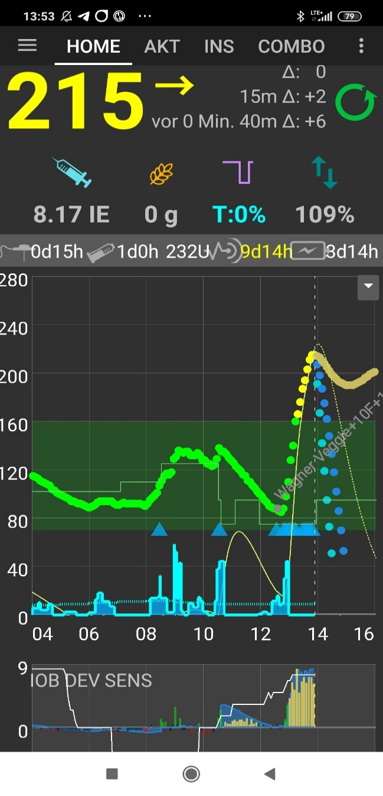

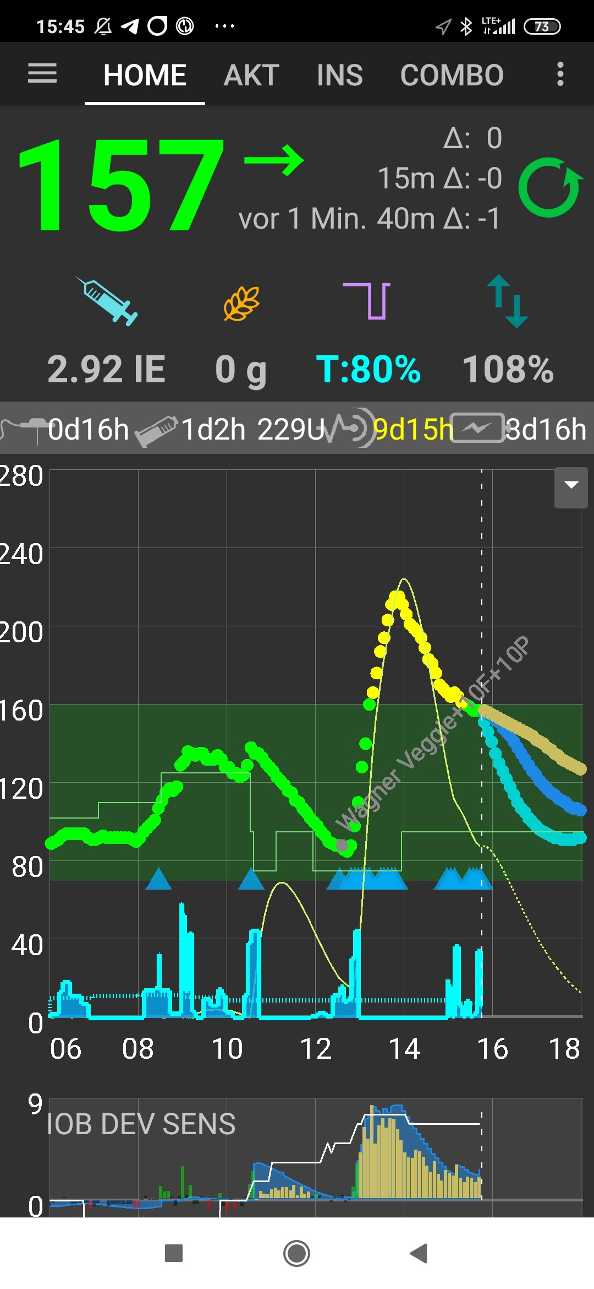

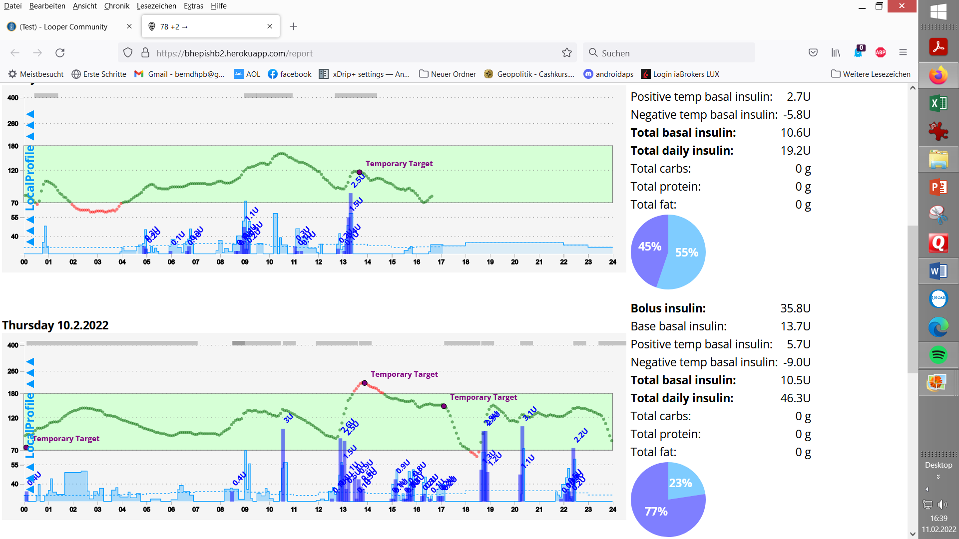

~ 17:30 h glucose sinks a bit too fast

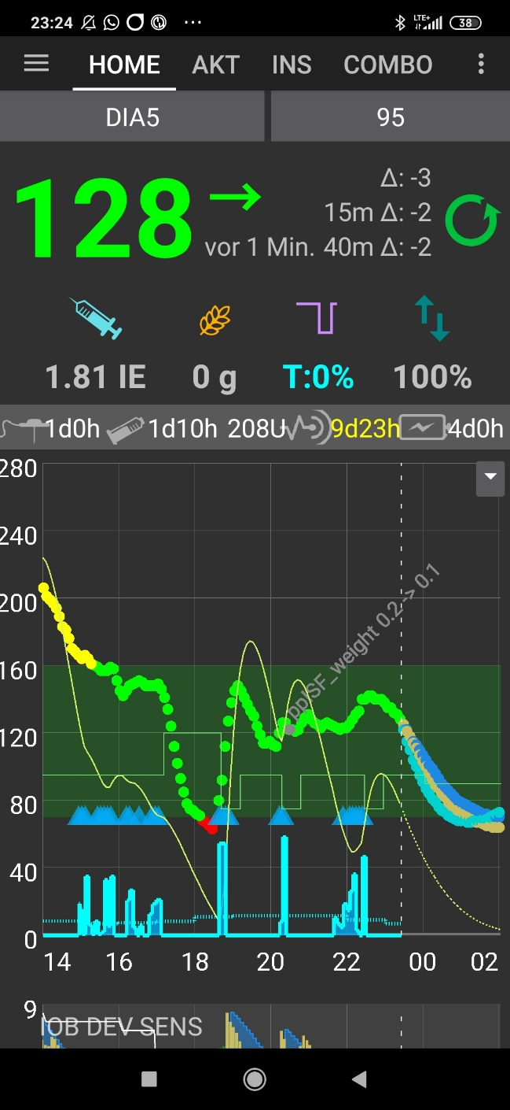

because a dogwalk coincided with

the „tail activity“ from the SMBs,

while nearly all carbs were digested

Finding improved settings using the Emulator

Primary goal: To limit the initial bg rise (which went up, briefly, to a 210 mg/dl peak).

Secondary goal: The hypo tendency in the end is worrisome, and certainly should not increase further.

bgAccel_ISF_weight drives the first SMBs that are best suited to limit initial rises of bg after meal start.

Limiting the peak height is also a good means to reduce hypo danger.

Moreover, hypo danger very often emanates from „over“-treating either high bg level (bg_ISF_weight? maybe also delta_ or pp_weights?), or duration (duraISF_weight).

A look into the effects of all the autoISF categories (and the underlying respective _weights) should help coming to a hypothesis, how to shift weights for desired improvement.

In the following table*)

* yellow markings: where stronger SMBs (lower resulting „ISF emul“) is desirable
* red markings, where weaker or no SMBs (higher „ISF emul“) is desirable

**\*)** *Note: The table is based on an older Emulator and autoISF version; . delta_ISF is no longer “offered” -> pp_ISF must be (and is better to be) used*

Findings (with references to the table shown below):

* Autosens (grey: AS orig => ISF AS) is not helpful and should be switched off
* delta_ISF_weight seems way too strong and leads to lowered ISFs in times when we would like to reduce SMBs already (red marked, W 14-23). Moreover, delta_ISF is responsible in lines 42 und 50 of the table for an extra of (0.9+0.8=) 1.7 U that contributes to going low in the end of the investigated meal time window.
* Above the blue line (line 15, 13:02 MEZ, 12:02 Z) we minimum like to retain the sizes of SMBs. As we like to take down the delta_ISF contributions, for keeping insulin supply for W12-15, we then must shrpen accel_ISF (and autoISF_max). To retain the SMB size like in AD12-15, an emulated ISF as in Y12-15 must result, with help from a lowered accel_ISF (X12-15).

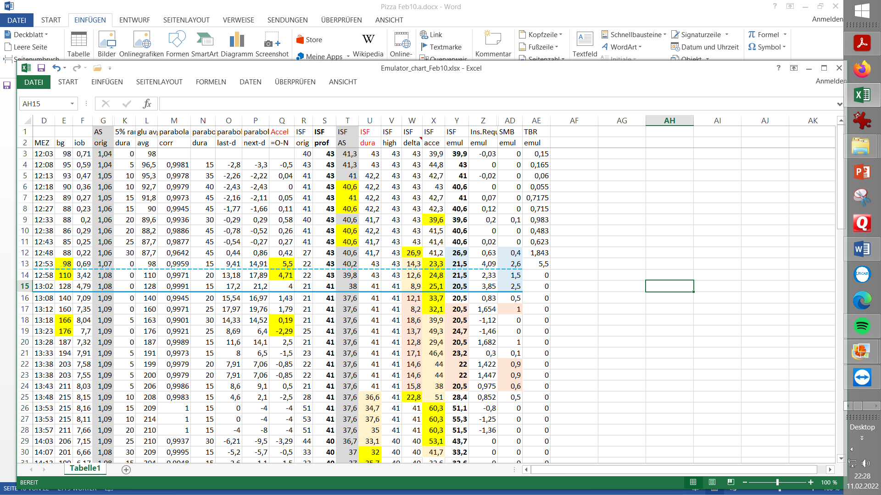

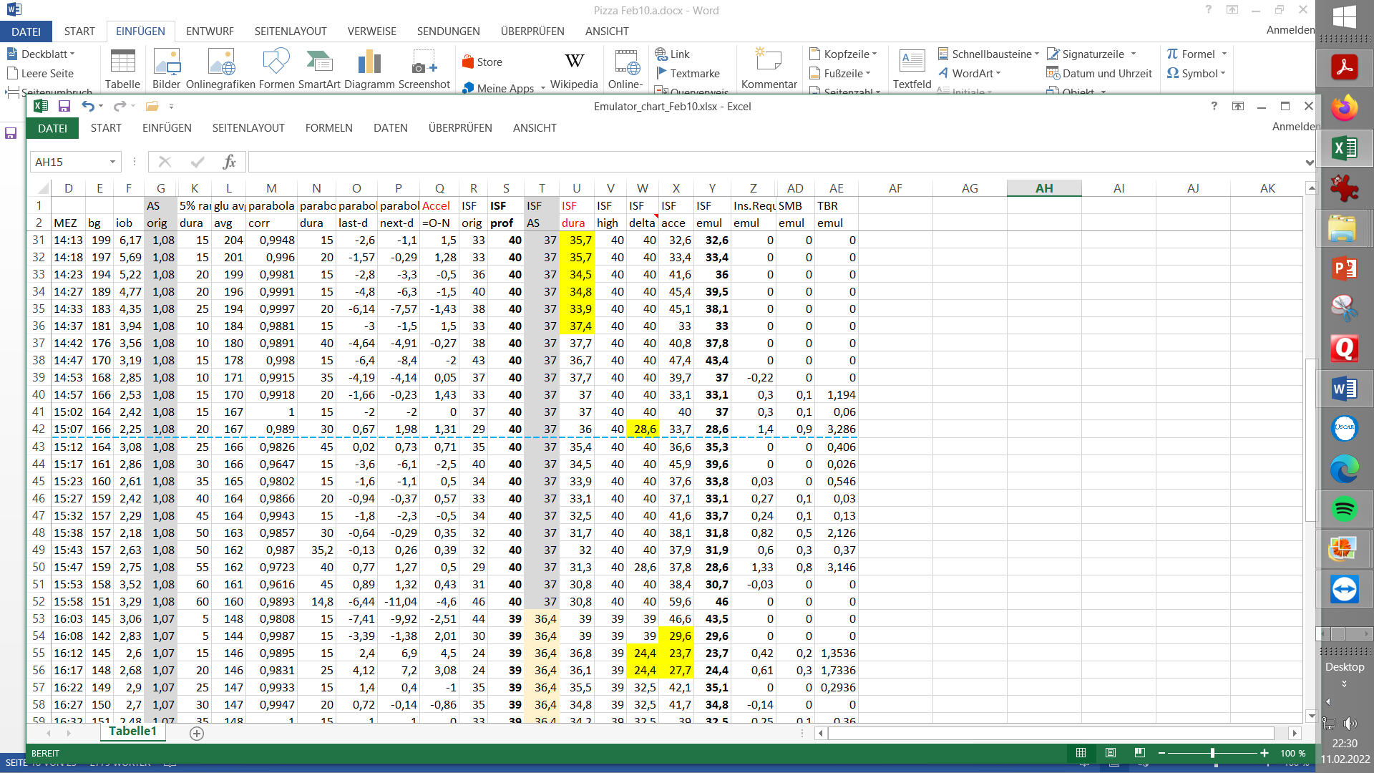

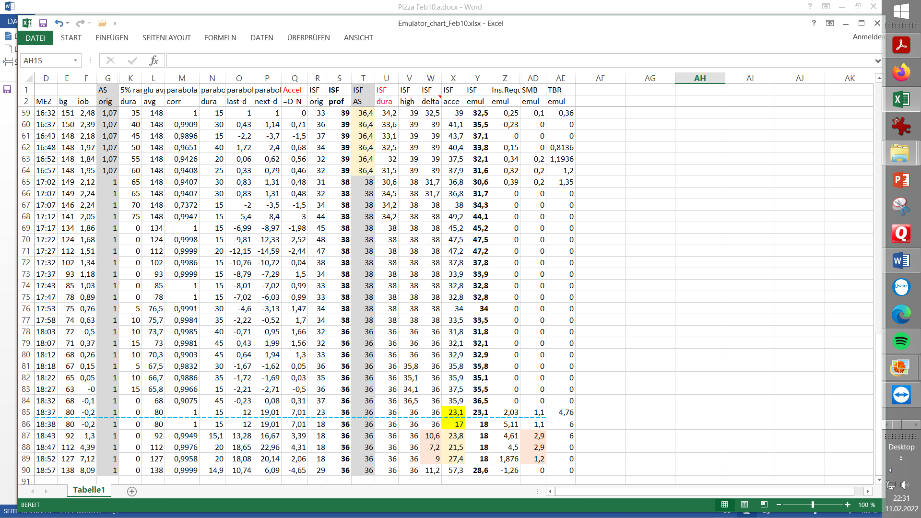

(Around 18:30 h is start of next meal)

Notes:

1. Lowering iobTH could be another measure against going low. However, we have seen the need for a high iob initially (when diet spectrum includes high carb foods).
2. Anything I conclude for pizza here had to be cross-checked with my other two “model meals” (low carb steak meal, and high/fast carb rice “pudding”; especially the latter also benefitted from the settings changes).
3. You could look into a similar table with the weight settings you are contemplating to *alternatively* try (see FCL e-book section 10.3)

The limitation of doing this is that, going down the new table (the additional “what-if”- related columns), whenever a first relevant effect occurs, *this would change everything thereafter*. So, you see (like also in the graph, example given on next page) *moments in which it would make a difference*

(a) first time effect and

(b) later *potential* effect*, if the situation (iob, bg) were remaining similar*.

Resulting tuning

Autosense interference is not helpful and will be shut off

pp-ISF_weight showed over long stretches a too strong lowering of ISF. It gets strongly reduced from 0.1 -> 0.02.

This measure was cross-checked using the Emulator and a “What-if” vdf (see section 10.3 in FCL e-book). Result see next graph: ,

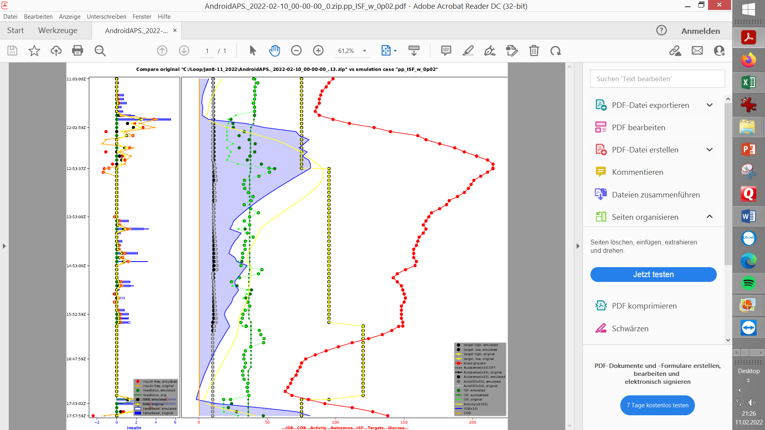

Investigating effect of reduced pp_ISF_weight (0.02, dark green points) vs. past setting (light green: ISF with 0.1 value) using the d.b. emulator:

In the mid and late stage of rising glucose, there would be an effect of lower insulin given.

Also after the max., there are a couple of instances where glucose jumps up briefly, and less insulin would be given with the reduced setting.

Note: A nice way to check an alternative setting *in real-time* is to make use of the Emulator with speech synthesis on the smartphone (see FCL e-book, section 11.2)

bgAccel_ISF_weight 0.16 is responsible for the early SMB sizes. It will be sharpened to 0.20 (later to 0.22), considering that some delta_ISF contribution will be reduced also in this phase. .

delta_ISF_weight ( 0.8) is reduced to 0.6

See table given on first page for all changed parameters.

Pizza meal 2

I ate *half of* a home-made Pizza, size of an European baking oven rack (ALDI Süd dough roll) with canned tomatoes, salami, mozarella, pre-fried eggplant, bell pepper, onions & garlic topping.

No initial bolus was given by the user (1,2 U at 11:13 is from automatic regulation towards the pre-lunch bg target of 74 mg/dl)

No carb announcement was made.

12:15 h lunch start.

As the AAPS main screen (below) shows, the oref(1) SMB+UAM algo dealt very well with the Pizza:

12:33 + 12:38 autoISF gave 2 SMBs, together 4.8 U

This provided excellent bg control up to around …

13:18 h …. when bg rose again and a third SMB (size: 2.3 U) was given.

Now, iobTH was exceeded.





~ 14;30 h CGM bump and triggered “last” SMB (1.70 U) “should not have happened”:

see last page, *off-topic remark*



12:38 PM my iobTH was first time exceeded => Temp SMB shut-off, and "only" 500%TBR (graph 3, 12:34 - :44).

12:44 PM basal was reduced to zero for half an hour, for safety reasons and to watch the further glucose development

01:18 PM iob had fallen below iobTH again, as more carbs of my pizza had required insulin.

At 01:18 PM the next big (2.3 U) SMB was triggered, and iobTH was exceeded again.

The zig-zag shaped blue iob curve (lower part of diagram 1) shows nicely, how – over many hours – the loop was able to keep up sufficient iob for digesting the pizza, without – thanks to my set iobTH - ever shooting up into iob levels that would be unsafe for me.

Overall, this ended up as a day with 99% TIR, which I find very satisfying on a day with half an oven rack*) of a pizza, in Full Closed Loop.

*) EU size

*Off topic –* The case contains a CGM abnormality which is separately discussed in Case study 1.5:

Another TT 74 is automatically set after the one **jumpy CGM value** around 14:30 h, leading to 1,7 U (02:38 PM) additional insulin due to the „fake“ strong rise.

This is not a problem with my settings, and the meal, but a CGM problem. It therefore is discussed further in Case study 1.5.

This CGM artefact made the situation risky with respect to going a bit too low between 17 and 18 h, and I had to watch out whether I need a snack, or whether I just get to a nice low starting bg for my upcoming dinner.

*Carb deviation -*The orange bars graph on bottom of diagram 1 is the "carb deviation"

This is **of very limited interest**, really, for “no carb inputs” Full Closed loopers.

While I did not tell my loop what I ate, my loop can tell me back (calculate), what I „must have consumed“ that would explain the glucose development (in light of the calculated insulin decay).

How the underlying “dynamic carb absorption” calculation works is explained in paragraph 1.2 of the “IC (carb ratio)…pdf” at <https://github.com/bernie4375/HCL-Meal-Mgt.-ISF-and-IC-settings>

For how, using (also) these retrospective calculations of deviations, the UAM loop judges *more carbs* probably to come (and providing a balance against hypo tendencies from the “tails” of the insulin already on board): See section 4.5.9 of the FCL e-book).

For a very brief “critical” period, the FCL loop may confront you with a *“ … grams carbs needed*” message on your AAPS main screen (below the – superfluous - cob=0 field). You may want to briefly estimate for yourself, whether, in fact, and very roughly, around *that* amount of carbs currently is un-digested (“on board”) from your last meal. This is almost always the case, only you kept your loop dumb about it, not bothering to do any eCarb inputs any longer.

Watch these messages develop in the next few loop cycles; usually they “melt down to zero” long before your glucose would approach the hypo zone.

Especially in your tuning phase, this might happen sometimes. Then take a small snack (or glucose tablets, if you realize it really late) AND safeguard against over-treatment of the bg rise that will follow: Use the hypoTT as in HCL, or also a simple odd temp. target should do in such cases now.